Ana Sayfa
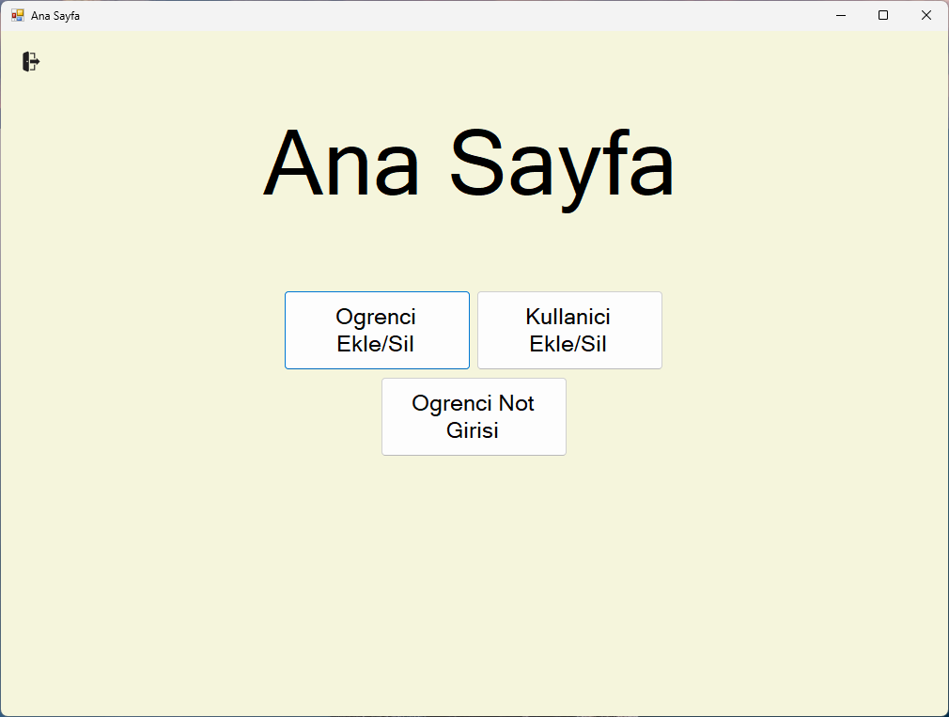
using System;
using System.Collections.Generic;
using System.ComponentModel;
using System.Data;
using System.Drawing;
using System.Linq;
using System.Text;
using System.Threading.Tasks;
using System.Windows.Forms;

namespace OgrenciBilgiSistemi
{
public partial class MainPage : Form
{
public MainPage()
{
InitializeComponent();
}

private void ogrenciEkSil_Click(object sender, EventArgs e)
{
Methods.FormSwitching.FormSwitch(this, new OgrenciEkleSil());
this.Close();
}

private void logOutBtn_Click(object sender, EventArgs e)
{
Methods.FormSwitching.FormSwitch(this, new LogIn());
this.Close();
}

private void MainPage_Load(object sender, EventArgs e)
{
if (Variables.Session.tempAccountType == "Admin" ||
Variables.Session.tempAccountType == "Both")
{
ogrenciEkSil.Enabled = true;
kullaniciEkDeg.Enabled = true;
}
else
{
ogrenciEkSil.Enabled = false;
kullaniciEkDeg.Enabled = false;
}
}

private void kullaniciEkDeg_Click(object sender, EventArgs e)
{
Methods.FormSwitching.FormSwitch(this, new kullaniciEkDeg());
this.Close();
}

private void ogrenciNot_Click(object sender, EventArgs e)
{
Methods.FormSwitching.FormSwitch(this, new ogrenciNotGirisi());
this.Close();
}
}
}

